9-2 System Proposal Document
Manickathan Martin

Single Sign-On (SSO)

IT-510-Q4070 Advanced Information Technology
Professor Daniel Neal
Southern New Hampshire University

June 26, 2014

9-2 System Proposal Document

System Proposal Document

Table of Contents
Revision History 6
Introduction 7
Background 7
Problem Statement. 7
Audience and Impacts. 8
Assumptions. 9
Constraints. 9
Dependencies. 9
Systems Requirements 9
Requirements Modeling. 9
Outputs 9
Inputs. 10
Processes. 10
Performance. 10
Controls and Security. 11
Data Process Model. 11
Structured English. 11
Context Diagram. 12
Data Flow Diagram. 13
Data Dictionary. 17
Entities. 17
Dataflow. 17
Process. 20
Data Store. 21
Data Elements. 21
Records. 22
BPMN Modeling Diagram. 23
Enterprise Data Modeling Diagram. 24
Object Modeling. 25
State Transition Diagram (STD). 25
Use Case Diagrams. 27
Systems Design 29
Specifications. 29
Design Guidelines and Principles. 29
Software Requirements. 30
Hardware Requirements. 30
Class Diagram 30
Sequence Diagrams. 31
Data Design. 33
ERD (Entity-Relationship Diagram). 33
3NF Table Design. 35
User Interface Design. 38
User-Centered Design. 39
HCI (Human Computer Interactions). 40
GUIs (Graphical User Interfaces). 42
Illustrates User Interface Design. 42
System Architecture. 47
System Hardware Architecture. 47
Security Server. 48
Web Server. 48
Application Server. 48
Database Server. 49
System Software Architecture. 49
Presentation Layer. 50
API. 51
Service Layer. 51
Data Layer. 51
Common Services. 51
High Level Software Architecture. 51
Corporate Organization and Culture. 53
Enterprise Resource Planning (ERP) and Total Cost of Ownership (TCO). 54
Interface Requirement, Integration, Scalability and Security. 55
Feasibility Analysis 56
Operational Feasibility. 56
Technical Feasibility. 57
Economic Feasibility. 57
Schedule Feasibility. 59
Work Breakdown Structure. 59
Gantt Chart. 61
Task Usage. 66
Resource Sheet. 69
Cost Table – By Resource. 69
Cost Table – By Task. 70
Resource Chart. 71
Resource Cost Overview. 72
Project Monitoring and Control Plan. 72
Ensure The Project Is Going Smoothly. 73
Ensure That All Controls Are Adhered To. 74
Defined critical path. 76
Gantt Chart. 77
Network Diagram. 78
Timeline. 80
Estimated Amount of Time for Implementation 80
Visual Representation of Timeline in Gantt Chart 80
Timeline Fullview 81
Summary of the Project 81
References 82

Revision History
Version | Date | Name | Description
1.0 | 7/1/2015 | SSO Project team | Initial Creation

Introduction
The system should create a single sign-on (SSO) for an organization’s employees to access Time Keeping, Expense Tracking, Payroll and Order Management systems. The project also aims to provide SSO functionality to the customers to different services including Order Management System. Also, develop a web portal to integrate Time Keeping, Expense Tracking and Payroll systems this can be accessed by company’s employees.
Background. Boston-based AMCE is a mid-sized company it has grown considerably and has made its first acquisition recently by purchasing the California-based SJT. ACME uses intranet applications for Time Keeping, Expense Tracking and Payroll processing. These are developed with their on authentication and authorization mechanism with their own database. All these applications are built with .Net Technologies. SJT has a web based sale force system that is configured to use forms authentication. ACME decided to use SJT sales force to enter, process, and manage customer orders in both companies. As part of the acquisition, ACME will keep its own Time Keeping system, Expense system and Payroll system and provides access to SJT’s employees. Also, SJT’s sales force system should be available to all the sales department employees in both companies. With these considerations in mind, ACME has made the decision to modify the applications to support the claim based single sign-on. ACME determined that the main change would be to introduce an issuer of claims for the company. ACME’s applications will trust this issuer to authenticate users.
Problem Statement. Each system needs its own authentication that makes it difficult for the employees to log into different systems separately to access each service. It is getting difficult for the employees to log into different systems as each system needs to authenticate them separately. ACME wants to work both organization’s Active Directories in a trusted environment and all applications have to work with single sign-on using centralized authentication control. ACME also provides different services to their customers and it would benefit if they get a single sign-on functionality to access all the services provided to them. ACME will develop a web portal to integrate Time Keeping, Expense Tracking and Payroll systems this can be accessed by both company’s employees.
Audience and Impacts. Enable internal and external audience to access their services through internet. Internal audience includes all the employees from ACME and SJT organizations and external audiences are people who use the order management system outside of the organization. This single sign-on project will impact the organization as a whole which includes following audience:
- Employees (Sales, HR, Management)
- Clients
- Finance/Accounting
- Sales Department
- External Vendors/Partners
- Steering committee ( CFO, CIO, Vice President)
The new system has to test and implement in parallel with the existing applications. Once the merging is done successfully and the new system is operational, the existing SJT Time Tracking will be phased out completely and SJT will use ACME’s Expense Tracking and Payroll systems for their organizational operations. The integrated web portal comes more efficient and streamlined with all modules in a single application. This will require training to employees to use the new system. This improved efficiency will lessen the burden of merging different system’s output together to make it as a consolidated one. Additional expense has to bear for the centralized authentication control.
Assumptions. The success of this project is depending on the input from stakeholders, senior management sponsorship, project budget, key project member’s availability and performance, accuracy of the project schedule dates, identification of the critical success factors (CSF) and domain expert consultants. CSF, also known as Key Results Areas (KRAs) is a common reference point to help everyone in the team to know exactly what is important for the success of the project.
Constraints. The development team will be responsible for the implementation of claim-based single sign-on features for the existing sites and the development of the web portal. One of the main constraints include studying the existing table structure and design of individual applications and cleaning up the legacy data before migrating to a new system. Budget and scope creep has to be monitored regularly and resource has to be allocated as per the project plan.
Dependencies. Users input and feedback are required to develop the web portal with proper workflow. Training should provide to the end user in each department respectively before going to the project live in production. We need to migrate all existing data before releasing the product.

Systems Requirements
Requirements Modeling. These are the requirements that we need to achieve in the implementation of this project.
Outputs. The system should provide an error page whenever an unauthorized access occurs from customer or employee. The system should create an attendance report, list of absent employees, salary slip including regular wage as well as overtime, list of Paid Leave and list of loss of pay leave, date wise expense report in each category, cumulative deductions for each employee and W2 for each employee. Facilities should be provided to create the list of orders and list of customers.
Inputs. The system should have a provision to enter the customer’s and employee’s credentials to login to the system and there should be necessary screens to enter employee information, employee education, and experience, work history, join date, etc. The system should have the facility to enter pay rate, attendance, available and incurred leave, overtime for each employee. All types of master data like category, customer type, department, bank, etc. have to be recorded through the system. The system should maintain the purchase history and screens should provide to enter sales orders and invoice.
Processes. The system should have a facility to validate the customer’s and employee’s credentials and system should process the attendance and salary of the employee. Leave updation, credit salary to each employee’s account, process customer order, receive customer payment and apply against their balance, process all employee expenses and reimburse the expenses to corresponding account, send email to customers, update sales tax for each order, keep track of tax and other benefits of each employee, generate W2 etc. has to handle by the system without any error. And of course, the system should have the facility to process the claim, provided by the claim issuer.
Performance. The system should be reliable, user-friendly, and robustness to handle the future growth of the organization. At the same time, monthly reports and process (eg. salary process) should not interfere with day to day activities of the system. And reports should be provided in the mailing format. The system must be operational seven days a week, 365 days a year and response time should be tolerable. And at last not least, the claim process should not increase the authentication and authorization time of the system.
Controls and Security. The system must maintain separate levels of application selection for customers and employees and must provide log-on security at the operating system level and at the application level. The system must maintain separate levels of security (eg. authorization) for employees, customers and the system administrator and should not allow users to access any of the system without proper authentication and authorization. Proper firewall trust settings should be there between the IT system and claim issuer and all transactions must have audit trails. The system must create an error log file that includes the error type, description, and time.
Data Process Model.

Structured English.
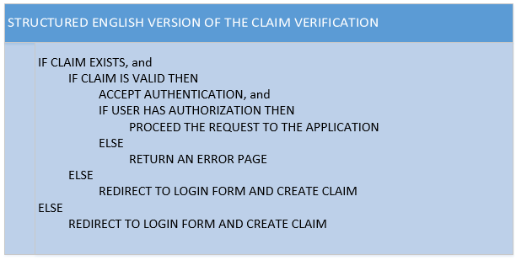

Context Diagram.
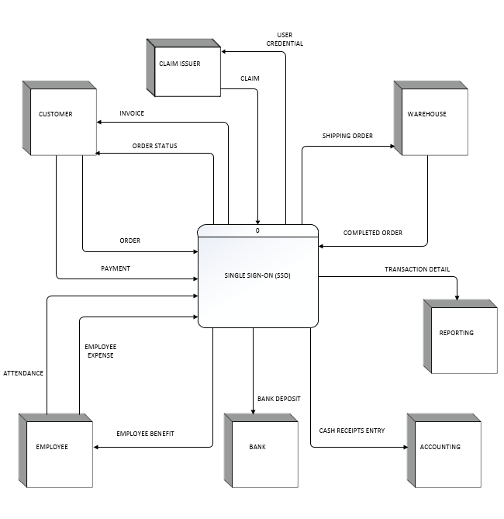
Context Diagram for the SSO system.

Data Flow Diagram.
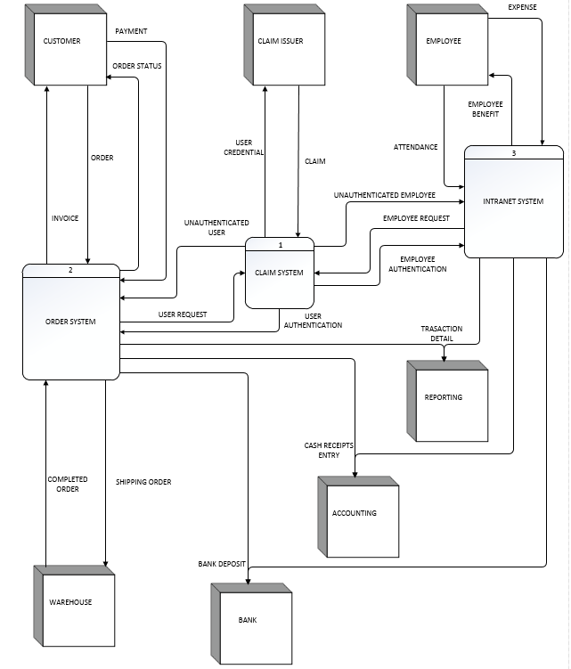
Diagram 0 DFD for the SSO system.

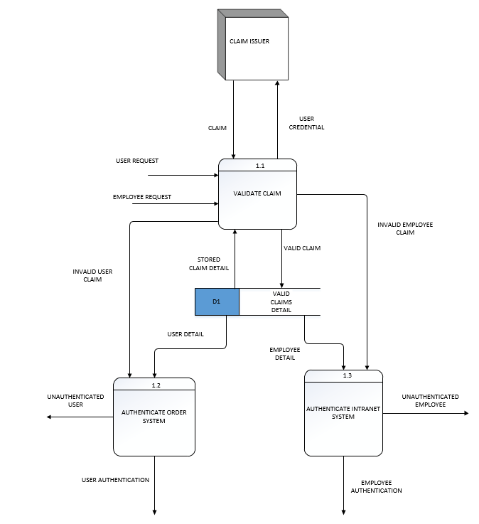
Diagram 1 DFD shows the details of CLAIM SYSTEM process in the SSO System.
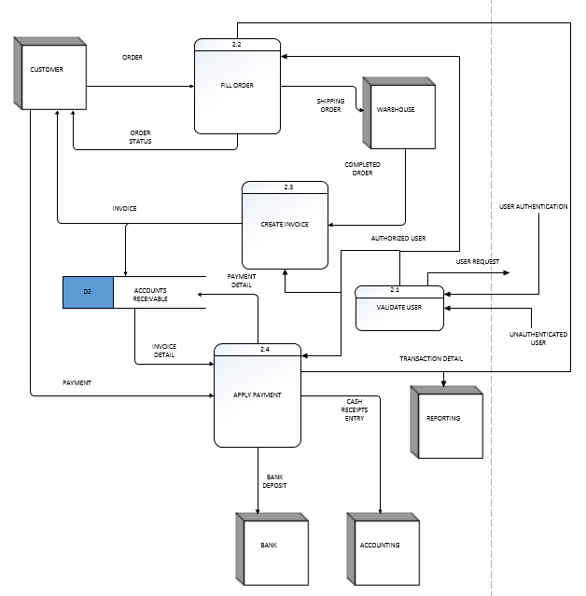
Diagram 2 DFD shows the details of ORDER SYSTEM process in the SSO System.
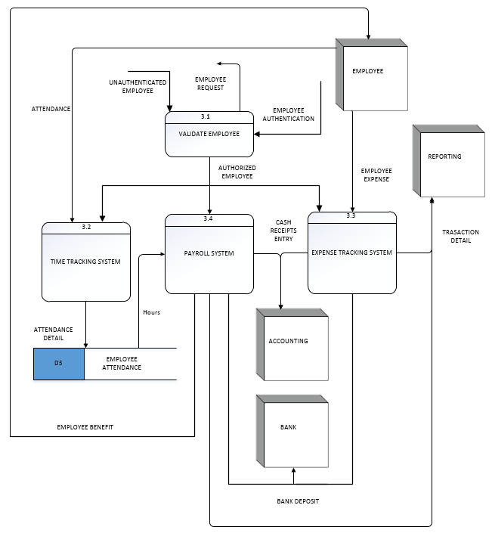
Diagram 3 DFD shows the details of INTRANET SYSTEM process in the SSO System.

Data Dictionary.

Entities.
Entity Name | Description | Input data flows | Output data flows
Customer | A person or an organization making purchase transaction with the company | Invoice, Order Status | Order, Payment
Employee | An employee is someone who works in the company | Employee Benefit | Attendance, Employee Expense
Claim Issuer | An outside organization who provides the support for claim based authentication | User Credential | Claim
Warehouse | Product currently available for shipment | Shipping Order | Completed Order
Bank | A bank is a financial institution that holds and controls all money transactions between the parties through authorized documents. | Bank Deposit
Reporting | Generates various reports for the entire system | Transaction Detail
Accounting | Handling all cash related transactions | Cash Receipts Entry

Dataflow.
Name | Description | Origin | Destination
Invoice | Accounting bill for the purchase of goods | SSO Process, Order System process,  Create Invoice Process | Customer Entity
Order Status | Status of the order indicates whether it is rejected or accepted | SSO Process, Order System process, Fill Order process | Customer Entity
Order | List of items selected to purchase | Customer Entity | SSO Process, Order System process, Fill Order process
Payment | Give money against the invoice | Customer Entity | SSO Process, Order System process, Apply Payment process
Attendance | List of days employee did their work | Employee Entity | SSO Process, Intranet System process, Time Tracking System
Employee Expense | Employee spent money in the company’s process | Employee Entity | SSO Process, Intranet System process, Expense Tracking System
Employee Benefit | What employee gets against their work and expense for the company | SSO Process, Intranet System process, Payroll System process | Employee Entity
Bank Deposit | Check of customer payment and employee benefits sending to the bank as a deposit | SSO Process, Intranet System process, Order System process, Apply Payment process, Payroll System process, Expense Tracking System process | Bank Entity
Cash Receipts Entry | Cash transactions posting to accounts | SSO Process, Intranet System process, Order System process, Apply Payment process, Payroll System process, Expense Tracking System process | Accounting Entity
Transaction Detail | Sales, attendance, salary like all types of transactions, keeping to generate report | SSO Process, Intranet System process, Order System process, Apply Payment Process, Payroll System process, Expense Tracking System process | Reporting Entity
Completed Order | Shipment is finished and ready to collect the payment | Warehouse Entity | SSO Process, Order System process, Create Invoice process
Shipping Order | List items to fill and ship to the customer | SSO process, Order System, Fill Order process | Warehouse Entity
User Credential | User name and password sending to the claim issuer for verification | SSO Process, Claim System process | Claim Issuer process
Claim | Return receipt from the claim issuer for the user credential | Claim Issuer process | SSO Process, Claim Issuer
Unauthenticated Employee | Indicates the employee is not authenticated | Claim System process | Intranet System process, Validate Employee process
Employee Request | Employee’s request for the transaction which will send for the authentication then proceed further | Intranet System process, Validate Employee process | Claim System process
Employee Authentication | Employee is authenticated and can continue with further process | Claim System process | Intranet System process, Validate Employee request
Unauthenticated User | Indicates the user (customer, sales rep) is not authenticated and can’t continue further | Claim System process | Order System process, Validate User process
User Request | User’s (customer, sales rep) request for the transaction which will send for the authentication then proceed further | Order System process, Validate User process | Claim System process
User Authentication | User (customer, sales rep) is authenticated and can continue with further process | Claim System process | Order System process, Validate User process
Invalid User Claim | User credentials are invalid and rejected the claim for all transactions | Validate Claim process | Authenticated Order System process
Invalid Employee Claim | Employee credentials are invalid and rejected the claim for all transactions | Validate Claim process | Authenticated Intranet System process
Valid Claim | Credentials are valid and got valid claim from the issuer and ready to cache (store) it for further transactions | Validate Claim process | Valid Claim Detail data store
Stored Claim Detail | Collect the already saved claim for verification with user credentials | Valid Claim Detail data store | Validate Claim process
User Detail | Send validated user details to order system to authenticate in the order system | Valid Claim Detail data store | Authenticated Order System process
Employee Detail | Send validated employee details to intranet system to authenticate in the intranet system | Valid Claim Detail data store | Authenticated Intranet System process
Authorized User | Authorized user for a particular operation | Validate User process | Create Invoice process, Apply Payment process, Fill Order process
Payment Detail | Payment related details are handled using this data flow and keeping that in a data store for further use | Apply Payment process | Accounts Receivable data store
Invoice Detail | Stored invoice details taking from the data store and sending for further process | Accounts Receivable data store | Apply Payment process
Authorized Employee | Authorized employee for a particular operation | Validate Employee process | Time Tracking System process, Payroll System process, Expense Tracking System process
Attendance Detail | Details of the attendance include paid leave are handling by this data flow | Time Tracking System process | Employee Attendance data store
Hours | Hours data flow includes working hours and paid leave details | Employee Attendance data store | Payroll System process
There is no default value, no alias and no limit in frequency for any of these data flows.

Process.
Name | Description | Process Number | Process Description
Single Sign-On (SSO) | Entire system considering as a single process | 0 | Handle all SSO related operations
Claim System | Here we handle the Claim based authentication. Depends on the user credentials input, it returns valid/invalid claim. | 1 | Authentication is controlled by this process
Order System | Sale and order related operations are handled here. These operations can be accessed by people outside of the company. | 2 | Order processing of items and payments are handled here
Intranet System | Attendance, payroll, expense tracking are handled here. It can only be accessed by company employees. | 3 | All employees related operations are handling by this process
Validate Claim | User credential verification and claim manipulations are happening here | 1.1 | Claim validations are happening here. If claims don't exist in claim store then send the user credentials to claim issuer and get the new claim
Authenticate Order System | Authentication process for entire Order system is happening here | 1.2 | All Order system related authentications are handled here
Authenticate Intranet System | Authentication process for the entire intranet system is happening here | 1.3 | All intranet systems related authentications are handled here
Validate User | This process validates the authenticated user and apply necessary authorization to access a particular operation | 2.1 | If the user is not yet authenticated it sends back that user to claim issuer to authenticate by claim system
Fill Order | Fill the order according to the customer pick list | 2.2 | Fill the order and make it ready to send to the customer
Create Invoice | Create invoice is happening here | 2.3 | This process creates the invoice to get the payment from the customer
Apply Payment | Receiving payment and store payment are happening here | 2.4 | Payment related operations are monitored here
Validate Employee | This process validates the authenticated employee and apply necessary authorization to access a particular operation | 3.1 | If the employee is not yet authenticated it sends back that employee to claim issuer to authenticate by claim system
Time Tracking System | Here we record the employee attendance | 3.2 | All attendance tracking and paid leave operations are handled here
Expense Tracking System | This process records the employee expense to decide which all expenses can be reimbursed | 3.3 | Here we control the expense reimbursement for the employee
Payroll System | Here we process the payroll using the hours worked and pay rate | 3.4 | This process is responsible for calculating salary and other benefits

Data Store.
Name | Description | Alias | Attribute name
Valid Claim Detail | Here we store the valid claim details for further use. This caching will helps to avoid the unnecessary routing to claim issuer until the claim is valid | D1 | Stored Claim Detail, Valid Claim, User Detail, Employee Detail
Accounts Receivable | Here we store all invoice and payment details for further use | D2 | Invoice, Payment Detail, Invoice Detail
Employee Attendance | Attendance of employee and payroll details are stored here | D3 | Hours, Attendance Detail

Data Elements.
Name | Description | Data Type | Acceptable Values | Mandatory? | Unique?
Product Number | The unique identifier of the item in the catalogue | Integer | 0 to 99999999 | Yes | Yes
Product Description | Short description of the product for the customer consumption | Character | min:1, max : 256 | No | No
Unit Cost | The current list price of the product | Currency | USD min: $0.00, max:$99999 | Yes | No
Employee Id | The unique identifier for the employee | Integer | 0 to 9999 | Yes | Yes
Employee Name | Name of the Employee | Character | min:4, max: 50 | Yes | No
Pay Rate | Rate of wage of the employee | Currency | USD min: $0.00, max: $999 | No | No
Hours Worked | How many hours worked to compute the salary | Number | min: 0.0, max: 99.9 | No | No
Paid Leave | Leave taken which have to pay as per policy | Number | min: 0.0, max: 10 | No | No
Reimburse Item Name | For what purpose the expense has been submitted | Character | min:1, max : 50 | No | Yes
Reimburse Amount | How much amount has to be reimbursed | Currency | USD min: $0.00, max: $999 | No | No
Address | Address of a customer or employee | Character | min:1, max : 1024 | No | No
Customer Id | Unique id of the customer | Integer | 0 to 9999 | Yes | Yes
Customer Name | Name of the customer | Character | min:4, max: 50 | Yes | No
Order Id | Unique id for the order | Integer | 0 to 9999 | Yes | Yes
Order Date | Date of the Order | Date Time | Today – 99/99/9999 | Yes | No
List of Product | List of products selected or purchase | List | List of product IDs | No | No
Invoice Id | Unique Id of the invoice | Integer | 0 to 9999 | Yes | Yes
Invoice Date | Date of invoice | Date Time | Today – 99/99/9999 | Yes | No
Invoice Amount | Invoice amount or bill amount – customer has to pay | Currency | USD min: $0.00, max: $999 | No | No
Account Id | Unique Id of the account | Integer | 0 to 9999 | Yes | Yes
Ledger Amount | Amount posted to the ledger | Currency | USD min: $0.00, max: $999 | No | No
CreditOrDebit | Is it credit or debit transaction | Boolean | True or False | No | No
Payment Id | Unique Id of the payment | Integer | 0 to 9999 | Yes | Yes
Paid Amount | Amount customer paid against the invoice | Currency | USD min: $0.00, max: $999 | No | No

Records.
Name | Description | Attribute name
Product | An item in the catalogue of products that are available for purchase by a customer | Product Number, Product Description, Unit Cost
Employee | An employee in the company | Employee Id, Employee Name,  Address, Pay Rate
Attendance | Attendance of an employee | Employee Id, Hours Worked,  Paid Leave
Expense | Expense of the employee to be reimbursed | Employee Id, Reimburse Item Name,  Reimburse Amount
Customer | Who is placing order and purchasing the product from the company | Customer Id, Customer Name, Address
Order | List of items customer wants to purchase | Order Id, Order Date, Customer Id  List of Product
Invoice | List of items customer purchased | Invoice Id, Invoice Date, List of Product,  Invoice Amount
Account | Recording money related transactions in the form account | Account Id, Ledger Amount, CreditorDebit
Payment | Customer pays the amount for the order | Payment Id, Customer Id, Paid Amount

BPMN Modeling Diagram.
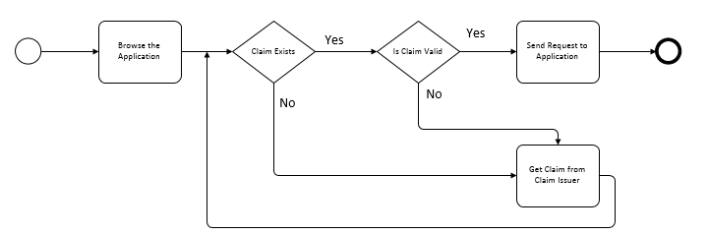Simple BPMN for claim validation process in SSO

Enterprise Data Modeling Diagram.
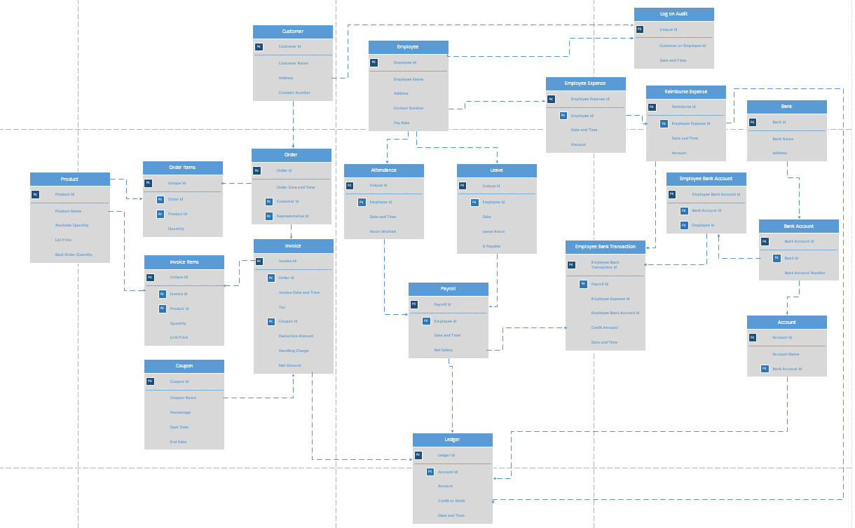

Object Modeling.

State Transition Diagram (STD).
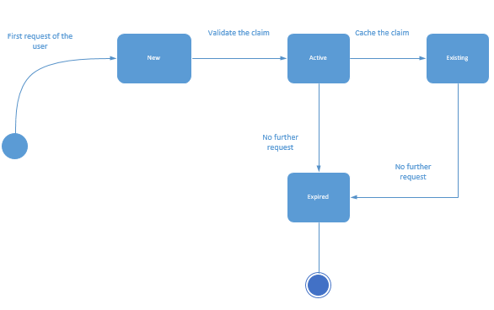

Activity Diagram.
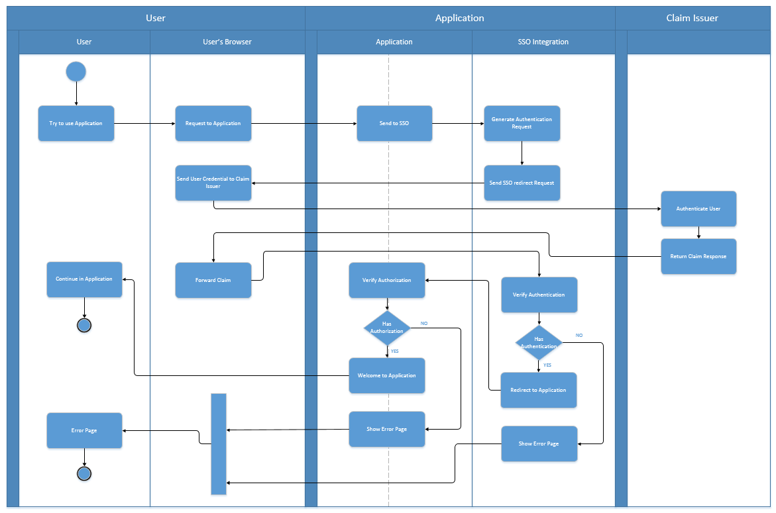
Activity diagram of SSO integration with swimlines

Use Case Diagrams.
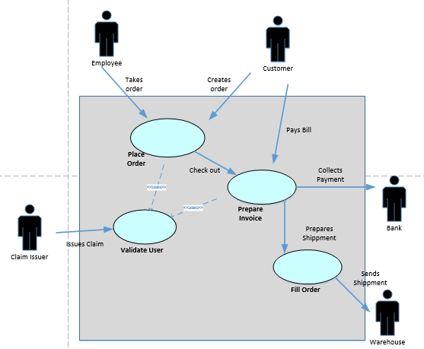
Use case diagram for ORDER SYSTEM with CLAIM validation.

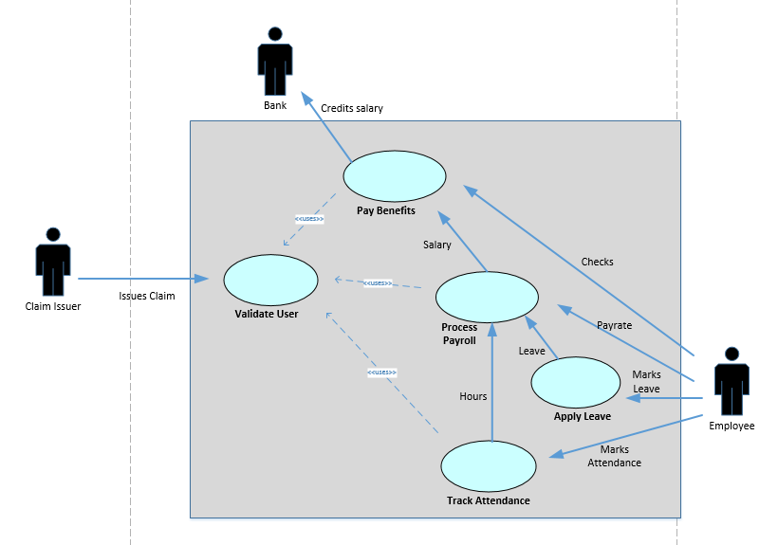
Use case diagram for PAYROLL and ATTENDANCE with CLAIM validation.

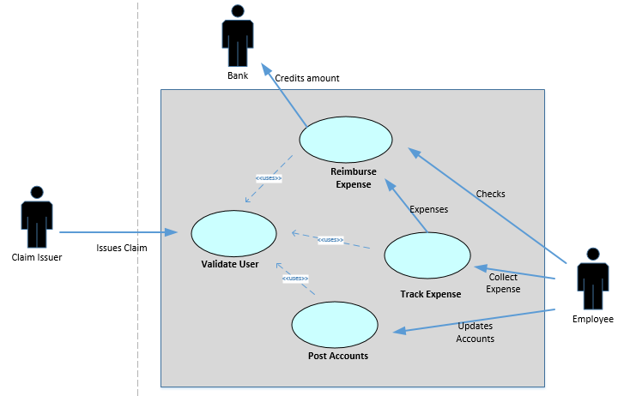
Use case diagram for EXPENSE TRACKING with CLAIM validation.

Systems Design
Specifications. This SSO project encompasses the development and implementation of a comprehensive, integrated system access approach for the applications with claim identity. This approach entails the application of technical skills to identify, and analyze the future growth of the company and the software should have the ability to support such expansion.
Design Guidelines and Principles. When appropriate, SSO designs:
- Reduce or eliminate separate login for each application.
- Reduce or eliminate data inconsistencies.

Software Requirements. We need to install these software for the implementation of this project, such as Windows operating system, Microsoft active directory, SQL Server database, .Net framework contains C# programming language and ASP.Net user interface, IIS 6 or above, Active Directory Federation Services (ADFS), Windows Identity Foundation (WIF)
Hardware Requirements. We need to acquire an azure cloud license to host the applications in the cloud. Before implementing claim-based approach we have to find a claim issuer who can handle all users’ credential and provide proper support for this system.
Class Diagram. A class diagram is a logical model, which evolves into a physical model and finally becomes a functioning information system.
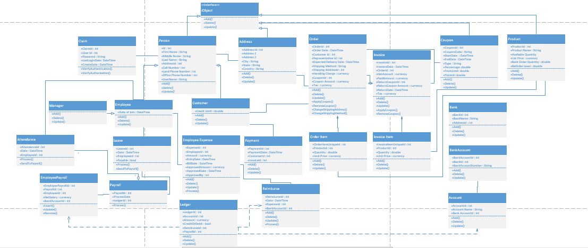
Sequence Diagrams. The Sequence Diagram models the collaboration of objects based on a time sequence. It shows how the objects interact with others in a particular scenario of a use case.
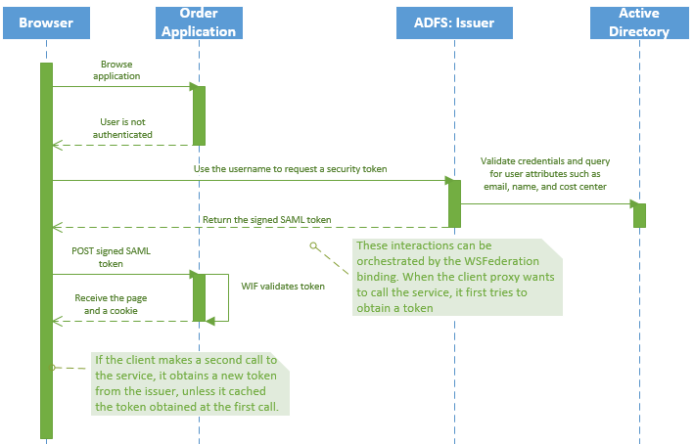
Sequence diagram of claim validation in Order Application
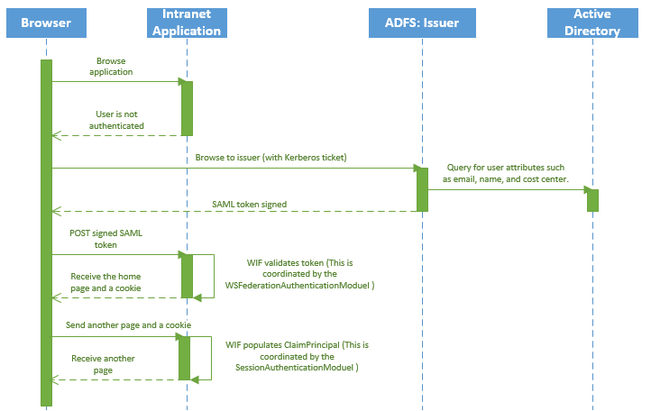
Sequence diagram of claim validation in Expense Tracking, Time Tracking & Payroll Applications

Data Design.

ERD (Entity-Relationship Diagram).
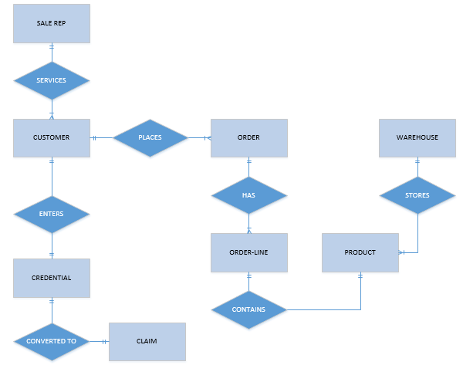
ERD for Order Management System with Claim
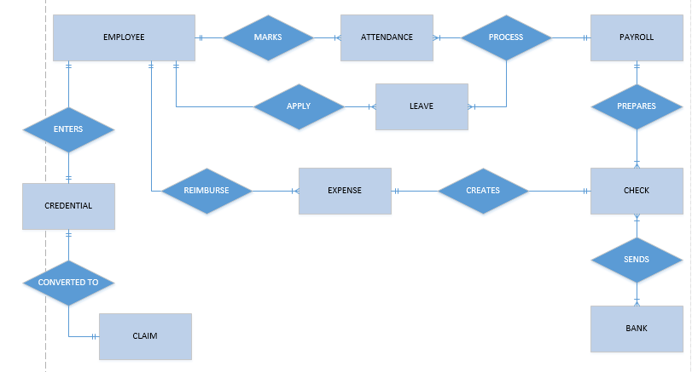
ERD for Payroll, Attendance and Expense Tracking with Claim

3NF Table Design.

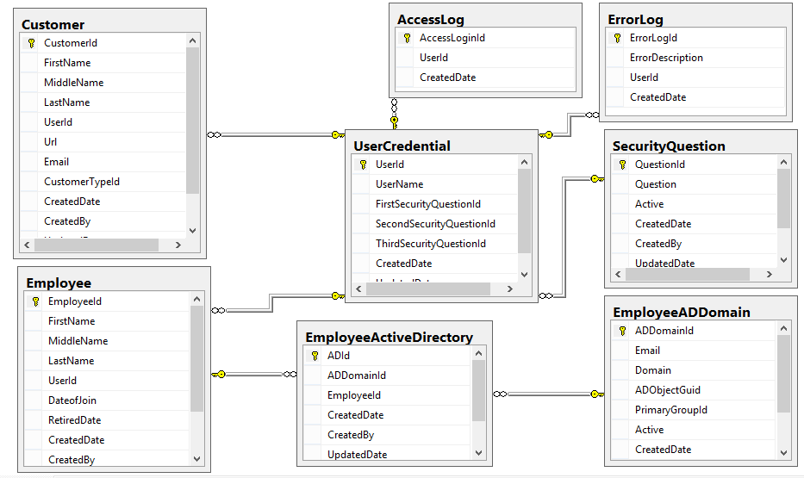
Tables for Login Verification and Error Log
We can import the active directory users to EmployeeActiveDirectory and EmployeeADDomain tables which can be used for the lookup screens of the system. ADObjectGuid filed is equal to the Object-Sid field in the active directory and PrimaryGroupId is matching with Primary-Group-Id in active directory. We have to create a windows scheduler/service program to download active directory changes to SQL Server table based on the USN-changed (update sequence number) value in the active directory. Here ADDomainId is the primary key. Email and AdObjectGuid are unique keys. Or in other words, there are three candidate keys available in EmployeeADDomain table. Employee can exist in more than one domain.
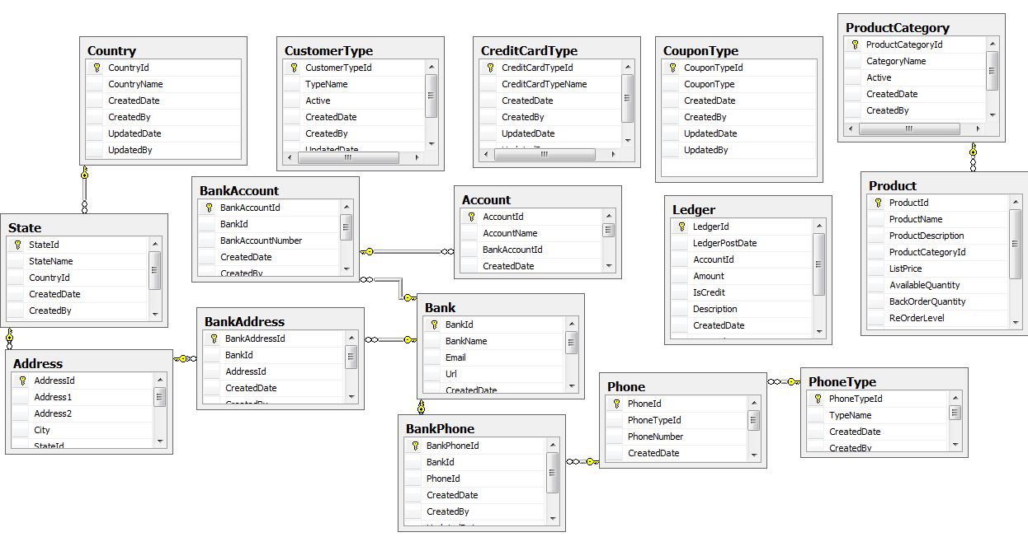
Other Master Tables

Tables in Order Management System
Tables for Payroll, Attendance and Time Tracking System.
User Interface Design. The user of this software product especially employees will be interfacing with all company software without worrying about their login credentials and permitting them to access the authorized software based on their intranet active directory credential defined under company policy. The product allows the user to get familiar with all applications in the company without actually having the responsibility of having a different login for each application. The customer will be allowed to keep one credential for all services provided by the company. Functional Decomposition Diagram (FDD) is portrayed below. FDD is a graphical representation of the business functions that starts with major functions in the company.
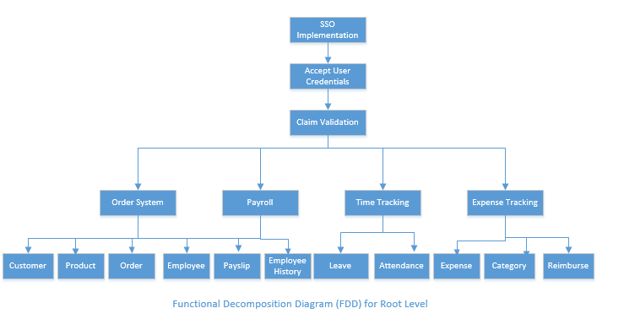
User-Centered Design. The proposed interface design is based on a combination of ergonomics, aesthetics, and interface technology. The system is more focused on the objectives and avoided unnecessary complications in UI level. It is designed in a format for easy to learn and remember with minimized input data problems by applying validating rules such as ‘sequence check’, ‘existence check’, ‘data type check’, ‘range check’, ‘reasonableness check’, ‘validity check’, ‘combination check’, ‘batch controls’ and providing various mask edit controls like ‘date time controls’ on the UI level. All these levels of verifications and validations help to increase the productivity. The users are going like the UI interface because it is designed in attractive layout and using familiar terms and images. One of the important parts of this UI design is, its help system and feedback system. These are organized in a way to access from anywhere from the software using shortcuts and it is developed with an enormous knowledge base acquired in the analysis phase. It’s professional and understandable user-centered design makes the system more attractive to anyone and the enforced rules to make sure the data integrity throughout the system. The user receives various outputs like formatted reports from the Order application and other Intranet applications which format in tabular with necessary drill-down facility for the each row if required. All printable outputs are in mailing format, which can be easily attached to the mail from the system itself.
HCI (Human Computer Interactions). This user interface is based on basic principles of human-computer interaction. This interface design concentrated on human ergonomic, cognitive, affective, and behavioral factors involved in user tasks, problem solving processes and interaction context. That means this design focused on human needs to describe how people work, learn, and interact with computers (Ergonomics), how an interface can be made attractive and easy to use (aesthetics), and how to provide the operational structure required to carry out the design objectives (interface technology). Part of the logical design of this information system is devising the HCI and it is important that the logical design accurately reflects the mental model of how the user views the system.
The user interface for this system will allow the user to easily login and generate Order, Payroll, etc., search for products, and modify details. The user should be presented with all main functions on the first user interface page to allow for the user to select the function to use without the need to navigate inward to find it. The interface will need to use tab focus marks to allow for navigation using a keyboard as much as possible to alleviate stress on the users' arms and hands caused by changing constantly from the keyboard to mouse. It will be accessible through a web interface to allow for centralized hosting and use by windows operating system.
This system is designed with the help of users by considering so many factors like the physical strengths and limitations of the users and what needs to be done to make the system audible, legible, safe, easy to use, learn and remember and how can the system be made pleasing to use and how to make the individual more productive. As part of the interview we have explored the key HCI concerns, including the ergonomic aspects, the system usability, how pleasing and enjoyable the system is, and how useful it is in supporting individual tasks. There were four to six key areas regarding HCI are considered in this UI design, like the usefulness and usability of the system; how it fits physical aspects; how it suits a user’s cognitive capability, whether it is engaging or aesthetically pleasing; and whether using the system is rewarded with desired consequences, and information processing and decision-making behavior.
A prototype has been developed to collect the feedback of UI design and made changes according to the response to enable the users to pick up the system quickly and not be put off. Online, interactive systems used GUI interfaces for the prototype. This is a best fit design to meet the organizational objective like better performance and greater overall well-being of the human involved in the system.
These are the main guidelines followed in this system design to achieve the HCI approach such as examined the task to be done and considered the fit among the human, computer, and task and identified what obstacles exist for the users in their attempts to accomplish their assigned tasks. Considered usability and examined the usage environment by creating use case scenarios that depict what is going on between users and the technology. Later we designed a prototype to accommodate diverse users and users with disabilities. All these designs are carried with the perceived usefulness and perceived ease of use from TAM (Technology Acceptance Model).
GUIs (Graphical User Interfaces). This section provides the graphic user interface for the SSO system. Employee and customer users will be able to log onto the system from computers within the ACME and SJT Company or from any computer connected to the internet. The company’s computers will access the system via a LAN connection while remote computers will access the system through an internet browser. The user interfaces displayed in this document will reflect the screens that will be seen when using the company’s computers. The user interface will be identical when viewed from outside of the company. The user login will be the same for all types of users when access from outside of the company. If the employee accesses the application from inside the company, there won’t be any extra login screen; it will be automatically authenticated based on their active directory settings. The access control function will determine the level of access based on the user level and type. The user type will be triggered by the user ID, and the appropriate menu will be displayed.
These are the key points considered to make the dialog in this system design such as meaningful communication that people understand what the computer is presenting or requesting and minimized user actions with the standard operation and consistency. On these GUI screens, feedback is often in the form of a message box with an OK button on it.
All these design interfaces help users and businesses get the information they need in and out of the system by addressing the objectives like matching the user interface to the task, making the user interface efficient, providing appropriate feedback to users, generating usable queries and improving the productivity of computer users.
Illustrates User Interface Design. Customer directly browse the Order application and add the items that they want. Once the customer click on the checkout button we can ask for the customer to login to the system. If the customer is already logged-in, we can redirect the customer to shipping address screen. If it is a new customer we need to display the registration/create account popup. The same login screen can be used whenever the employee tries to login from outside of the company’s intranet.
Shopping cart page
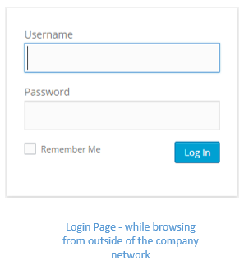
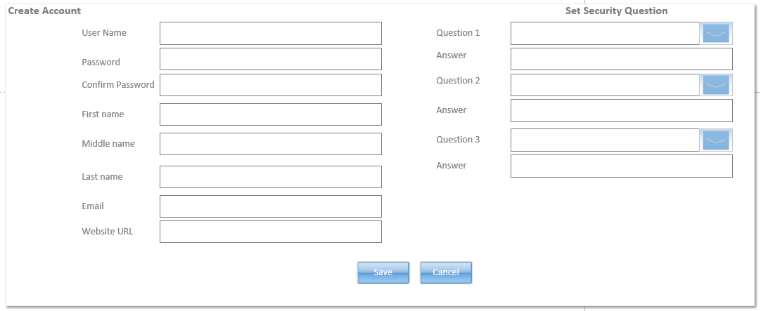

Collecting shipping address from the customer
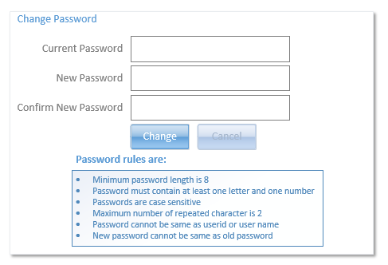
Screen to change the password for the customers.
The first page for the employees is portrayed below. They will have an admin interface of the Order system.
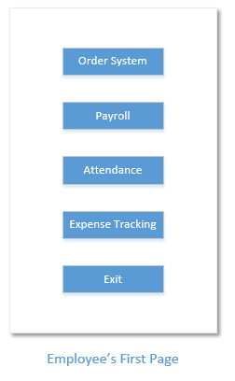
This is the screen available to employees to view the individual customer detail. Employee can’t see the customer’s security question and answers. The Customer Type field is automatically populated based on the order history. This field is available only to Employee view.
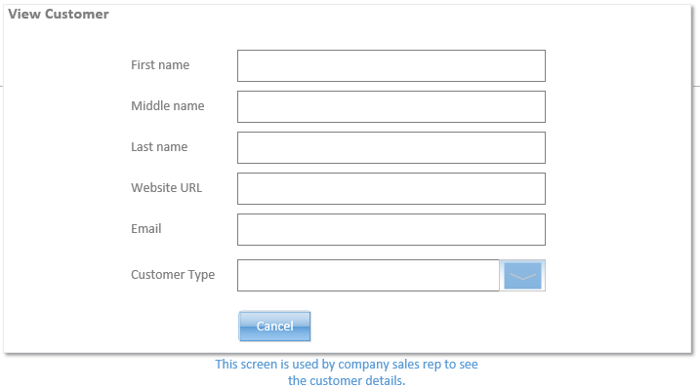
Employee’s password reset and other password verification are handled through Active Directory. So there is no specific screen for that at the software level. There is no provision to add employee from the list screen, it has to import from Active Directory. Same type of list screen is available for the customer with Add new button at the top of the grid.
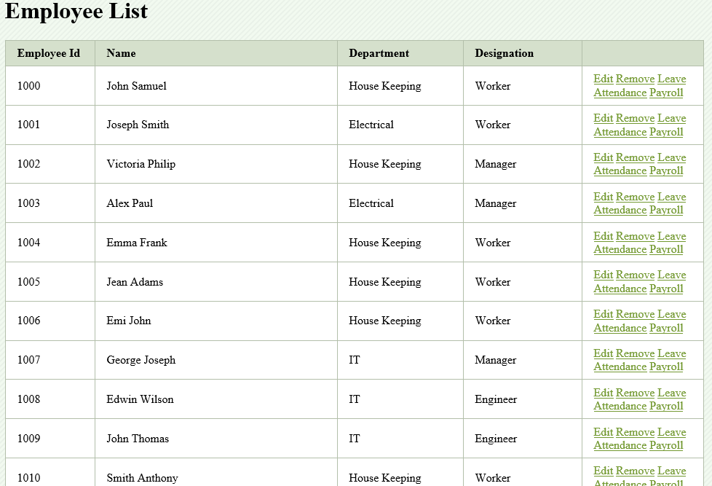

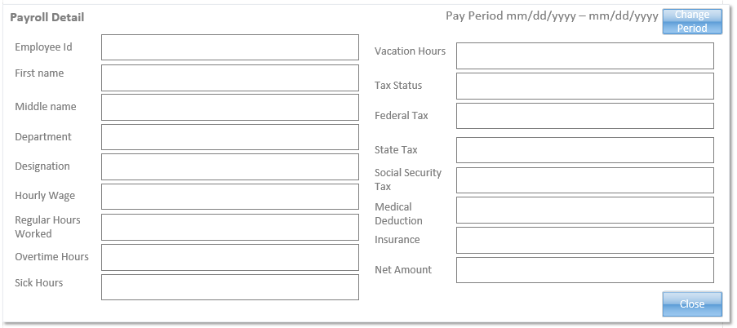
Screen to view the payroll of a particular employee for the selected pay period.

System Architecture. System architecture translates the logical design of an information system into a physical structure that includes hardware, software, network support, processing methods, and security. All of our existing applications are built with .NET technologies. In order to integrate single sign-on with existing applications and to create the web portal, we can use C# as the programming language with ASP.NET as user interface and SQL Server as the backend database.

System Hardware Architecture. The following diagram shows the logical hardware architecture for SSO.
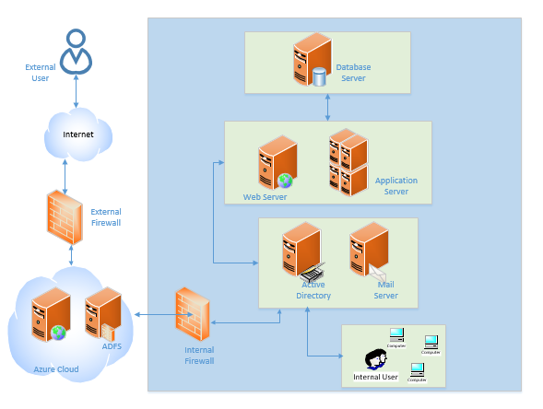
Security Server. The Security Server (i.e., Active Directory and Active Directory Federation Services) hosts all valid users (Domain Employees and Customers) and is used as an Identity source for authenticating SSO users at appropriate layers of the architecture.
Web Server. The Web Server will host the SSO web application that is accessed via external and internal parties (i.e., customers and employees). This server will provide application screens needed to support the user community, process requests generated by users, and route them to the appropriate subsystem.
Application Server. The Application Server will host all services exposed via the Service Layer. It will be responsible for receiving service requests generated by the UI, and in conjunction with other layers within the architecture, provide users access to the information stored in the Database Server. Lastly, it will also support the Help subsystem by providing a way of presenting information to users to help them use software more effectively by processing requests from the user interface (UI) via HTTP and responding with the appropriate help information.
Database Server. The Database Server will store any records created by the SSO application as well as provide data to support queries. The server will also be responsible for acquiring data of interest from other SSO systems as well as other specific systems of interest. SQL Server will be the best suitable database for this solution which can be moved to Azure eventually.

System Software Architecture. The SSO application consists of a multi-tiered and multi-layered NET architecture based on the Microsoft .NET 4.0 Framework. This approach allows the architecture to be separated into logical layers, with each layer of the application being responsible for a specific piece of functionality or module, while typically interacting only with the layer below it. The SSO layered architecture is depicted below. All database operations have to be routed through the Data Layer. There is no direct interaction between any other layer and database.
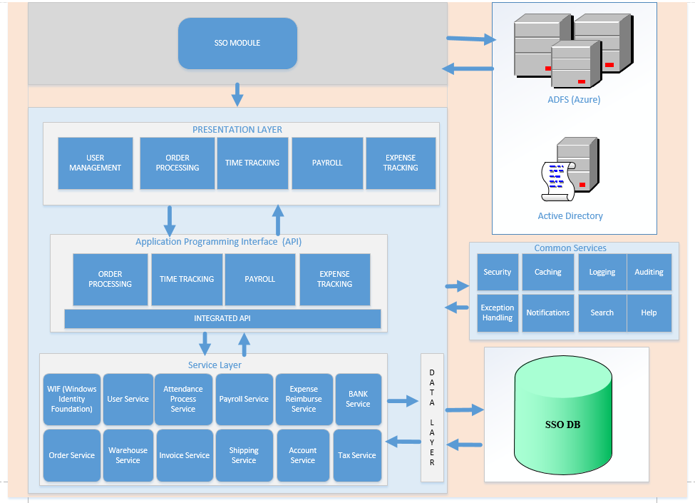
Components of the SSO project

Presentation Layer. The SSO presentation layer will consist of a web browser-based ASP.Net application that contains the components that implement and display the user interface and manage user interaction. This layer includes controls (.NET) for user input and display, in addition to components that organize user interaction. It will be built using the latest Microsoft UI technologies and will provide the user with a rich application experience. This approach offers benefits over a web-based model in that:
- ASP.Net application maintains state on the local workstation or laptop
- It communicates only with servers or SOA services when additional data is required
- Lookup data can be cached on the client workstation for faster access
- User interface responsiveness is improved as it is not regenerated during each interaction

API. The SSO API (Application Programming Interface) layer contains the software components and associated classes that abstract and decouple the application’s business logic from its presentation and data access logic. These components centralize business functionality to make the application easier to extend and maintain.
Service Layer. The SSO service layer defines the business operations that can be performed by this application as well as the data to be exchanged between the presentation layer or API layer and data layer.
Data Layer. The SSO Data Access Layer (DAL) is a collection of classes that provides access to data stored in the SSO database(s). The DAL will use Microsoft Framework as a means of providing a framework (through the mapping of relational data into objects) that allow developers to query, filter and modify data in an object-oriented manner, without having to construct application-specific data access logic, which can be both complex and error-prone if not implemented correctly.
Common Services. This layer provides the SSO services available across all the other architecture layers. These services include Security, Logging, Exception Handling, Auditing, Notification, Search, Help, and Caching.
A Service Oriented Architecture (SOA) can best be thought of as a way of making pieces of existing functionality available to other systems (exposing through web services) so that they can be used (or ‘consumed’) either as part of a new application or to greatly enhance existing ones by reusing functionality that is already present in the system.
High Level Software Architecture. Claim-based approach is the best suit for the SSO integration and that can be implemented based on Windows Identity Foundation (WIF). Claims decouple your applications from the details of user identity and claims work in conjunction with existing security systems that will reduce the technical obstacles. Claims can take advantage of existing active directory information since the user information was already in Active Directory, the claims-based identity solution would not require changing the Active Directory schema to suit any specific application. The process of validating credentials is delegated to a claims issuer and it can be achieved by configuring Windows Identity Foundation (WIF) WSFederationAuthenticationModule within the ASP.NET pipeline. WIF will work with Active Directory Federation Services (ADFS) proxy role that provides intermediary services between an Internet client and an ADFS server that is behind a firewall.
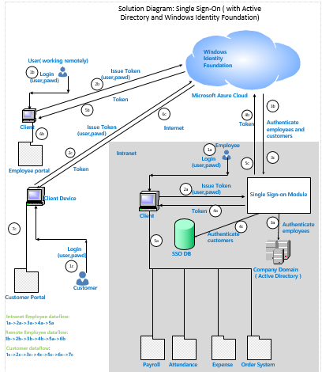
Solution Diagram

Corporate Organization and Culture. This solution diagram helps to understand the corporate organization and the culture of the company. This diagram depicted the applications needed for the day to day operations of the company as well as the users who all are involved in the company’s operations. This organization is a complex system composed of interrelated and interdependent subsystems like Payroll, Attendance (time tracking), Expense Tracking and Order applications. Organizations and teams can also be organized virtually with remote members connected electronically who are not in the same physical workspace. This SSO project’s common login with a centralized user management approach removes the barriers to handling the size and culture of the organization, location and future growth potentials of the company. We will create a prototype to facilitate the integration of the information system and culture of the organization. Once the prototype satisfies the culture requirement, later we can convert the prototype to a working system. According our requirement analysis, we have found that, the organization’s culture support a client-server model. To reuse the existing functionalities and make it easy for future support, service oriented client-server model is the best architecture for this organization.
Enterprise Resource Planning (ERP) and Total Cost of Ownership (TCO). SSO implementation is a crucial benefit for an ERP system to bring all related software under one umbrella. It helps the ERP system to maintain one login and one user management for all applications belongs to the ERP and while considering the future, if we want to add any other new application like ‘evaluate performance’ of the employees, we can easily integrate such applications under the ERP with a single authentication with the help of this SSO project. In all means, the benefits of the proposed system outweigh the estimated costs or the total cost of ownership (TCO). As part of the acquisition, we have to implement a system to bring all employees under the main company and we can’t do this same task in every future acquisition. If we implement this project now, we are preparing the company to go for another acquisition without worrying about the IT integration. Moreover, this approach helps to reduce the time and avoid the difficulty to maintain different authentications for each application, as well as we can configure all applications in one application server and maintain all application data in one database server instead of keeping in isolated servers for each application. These all things will reduce the TCO and helps to get benefits from this implementation.
Interface Requirement, Integration, Scalability and Security. We need to configure the internal firewall and acquire an azure license to host the application in the cloud. These are the main interfaces required for this software implementation rather than the hardware systems such as web server, application server, database server, security server with active directory settings. Service Oriented Architecture (SOA) type implementation is a benefit to maintain scalability and integrity of the system. Implementing with SOA architecture is an advantage for the future maintenance and upgrade of the system. If we want to add any other functionalities or modules at a later time we can include corresponding service layer and UI layer without changing the rest of the application. SOA will be configured as part of the deployment. Whenever we want to switch the claim issuer or move to any other type of identity provider instead of Windows Identity Foundation (WIF) and Azure that can be handled through the configuration mapping by replacing the issuer and WIF. Because of the loosely coupled architecture, system will be more scalable and reliable as well as system will be hosted in Azure and the company will be charged only for the resources like disk space, number of server web server and database server which are used in day to operations. This will reduce the initial cost and we do not need to pay for the resources that we are not using. Once we moved to Azure, we can be configured the service to create backup and other patch updations in Azure itself. Until that time, we have to create a schedule for database backup on our database server. Infrastructure level upgrade and maintenance will be handled by Azure itself that will avoid the extra burdens in IT department. Azure will handle the security related issues in cloud level and internal firewall will protect from the security threats happening to the company intranet.
Feasibility Analysis.
Operational Feasibility. Here, we are talking about the proposed system will be used effectively after it has been developed and social factors like how the organizational changes will affect the working lives of those affected by the system.
Both companies have different applications and as part of the merging, we need to bring all employees and customers under one organization. Because of that, management insists on using this new web portal for the day to day operations. According to the management and users, this solution will reduce the overburden of login to different applications and it helps to save time which can be utilized for the company’s other operations. Not only that, mostly it helps to reduce staffs in managerial level, especially in IT management and Sales management because all of the management work will come under one organization and the overburden of IT security and other aspects of the organization will be handled in one place. Most of the acquisitions will have an effect on the workforce in the form of shuffling or reduction. To avoid the workforce reduction, the company can introduce a new hierarchy in the organization level like regional managers and co-operative office or head office management. Such decision has to come from the top management of the company. There won't be any other workforce reduction in the middle level.
Basic level training should provide to the users of the system. Once they get hands-on then the users can handle the rest of the operations without much training. All department representatives should be included in the planning phase from the beginning itself to get an understanding of the system and what are the changes going to happen in their department. We can expect, better performance and efficiency improvement in the employee level because it will reduce the unnecessary logins and keeping different credentials for different applications. Customers will also happy to support the new system. As per their point of view, they can access the allowed applications without further changes compared to the existing system and getting the advantage of single sign-on to access all services provided to them. And they may feel they are doing business with a single entity instead of considering as different units.
Technical Feasibility. Existing applications are built in .NET technologies and both companies are using similar applications in the same technology. Because of that reason, we are going to use .NET technology for the new solution. This will help the existing IT team to handle this solution without further hurdles. Claim implementation is common in these days and most of the IT staff has that knowledge. This is a common implementation for a company which has offices in different locations. Microsoft explained the same solution on the MSDN site. If any of the IT staff doesn't have this knowledge, it is easy to acquire from the internet in recent days. This solution is well suitable for the future expansion of the company and Order application will move to the cloud, like Azure. ADFS implementation will help to move the applications to Azure without further changes. The system will be able to handle the upcoming transaction volume and once we move to azure, azure will take care the scalability issues and which solves the subsequent growth in volume. One of the advantages of Azure is that we do not need to pay for the infrastructure as of now which is required at a later time. We can create a prototype which can be tested in one of this company and later once the application development is over, we can implement in both places. One of the other advantages of the prototype is that we can convert the prototype into a working model depends on the prototype nature like error free and satisfying with the requirement.
Economic Feasibility. The benefits of the proposed system outweigh the estimated costs called as total cost of ownership (TCO).
There won't be any need for new staff to implement this solution; it can be achieved by the existing team itself. As of now, all of our systems have the necessary capacity to run the existing .NET applications and we are going with the same technology. In that case, we do not need much software or hardware changes for this solution. Maximum we have to add the cloud package to the already installed .NET framework. We do not need to pay anything extra for this software, but we have to pay for the infrastructure that we are using in each month in the cloud. As compared to the initial cost, this will be a very less and it can be paid monthly or yearly. It won't be a big liability for the company because the company is going to pay according to the usage of each month as per the cloud platform infrastructure. We have to acquire an azure cloud license and its payment is considered as part of the infrastructure usage which can be paid monthly or yearly.
Our new solution is matched with the existing applications because of that the training will be minimized and it won't be a big cost while considering the economic feasibility.
If we decided not to develop this solution, basically it is going to make much impact on the operational level and which intern affect the economy of the company in future. As consider the operation prospect and growth, it is better to implement as part of this first acquisition itself.
While considering intangible benefits, company's sales representatives will get more benefits compared to any other department. Sales department’s employees can handle their customers at one place instead of using multiple applications and preparing a cumulative report using some other tools like excel. They will get a better understanding of their customer’s balance from a single place itself. Another advantage, we do not need to send two reports to the customers who are part of both companies. We can handle such common customers in single software, basically that make a good impression about the company in the market, which helps to improve the goodwill of the company in the future. Another advantage is getting on the payroll side. We do not need to run two payrolls for these two companies. We can make it as a single transaction which will happen in the same day for the entire company instead handling separately in the different region office or in new acquisition office. All these things present the company to the world as it is capable to handle the acquisition smoothly and which will be a good impact on the company's image and goodwill and getting ready to further acquisitions.
Schedule Feasibility. IT team is able to handle any scheduling job, software license renewals and update necessary patches at the right time. As the situation demands, this project has to be implemented as early as possible otherwise the workload will be more because of the accumulation of day to day data which has to move to the new system. Even the situation is like this, we do not need to put the IT team in accelerated schedule that may cause to create more errors in the development and testing may take more time. Instead of that start the project as soon as possible and give sufficient time to the development and testing before going into production. We have to cut off a date to track the project status properly and we can make one of our teammates as project manager who can handle the situation smoothly.
Work Breakdown Structure. According to this project plan, the Project Manager is going to handle the Review Contract, Planning Process, Execution & Monitoring and Closing Process. System Analyst will work on System gathering under the project manager’s supervision because the project manager is the responsible person for the entire project. The Architect will take care the design phase and developers are going to work in development phase. Technical Writer is working on preparing training materials and Tester will work in validation phase and user acceptance test. Users will also involve in the user acceptance test with Testers and approve the functionalities based on the outcome. Deployment Expert will help in deployment work. All these works are managed by the project manager and the project manager will be the key person to respond to any queries regarding the project. Here is the work breakdown structure for the project.
WBS ID | Task ID | Description | Duration (Days) | Predecessor (Task)
1 |  | Project Single Sign On
1.1 |  | Project Management
1.1.1 | 1 | Initiation Processes | 3
1.1.2 |  | Planning Process
1.1.2.1 | 2 | Define Scope | 1.5 | 1
1.1.2.2 | 3 | Develop Project Schedule | 2 | 2
1.1.2.3 | 4 | Develop Risk Plan | 2.5 | 3
1.1.2.4 | 5 | Plan for Quality | 2 | 4
1.1.3 | 6 | Execution ,Monitoring & Controlling Processes | 93 | 5
1.1.4 | 7 | Closing Process | 1 | 6
1.2 |  | System Analysis and Requirements Gathering
1.2.1 | 8 | Workflow/Need Analysis and Modeling | 4 | 1
1.2.2 | 9 | Requirements Gathering | 2 | 5
1.2.3 | 10 | Documentation Sign off | 2 | 6
1.3 |  | System Design And Development
1.3.1 | 11 | Design Phase | 11 | 7
1.3.2 |  | Development Phase |  | 8
1.3.2.1 | 12 | Review Functional Requirements for SSO integration
1.3.2.2 | 13 | Review Functional Requirements for Web Portal and Remote Login
1.3.2.3 | 14 | Implement SSO with Active Directory and Windows Identity in Cloud | 3
1.3.2.4 | 15 | Integrate SSO to Existing internal Applications | 5
1.3.2.5 | 16 | Develop and Unit Test Employee web Portals | 2
1.3.2.6 | 17 | Develop and Unit test Customer portal | 2
1.3.2.7 | 18 | Create Application Programming Interfaces for existing apps | 5
1.3.2.8 | 19 | Create script to merge SJT's data with ACME's database | 4
1.3.2.9 | 20 | Integrate SSO to Customer Portal and Employee Web Portal | 3
1.4 |  | Validation and Go Live
1.4.1 | 21 | Functional Testing | 21 | 20
1.4.2 | 22 | Integration Testing | 18 | 21
1.4.3 | 23 | Prepare Training materials | 9 | 22
1.4.4 | 24 | User Acceptance Test and Training | 17 | 23
1.4.5 | 25 | Documentation | 8 | 24
1.4.6 |  | Production Deployment
1.4.6.1 | 26 | Create Backups and Setup Roll Back plans | 2 | 25
1.4.6.2 | 27 | Set up Cloud Environment and Activate Licenses for Azure | 4 | 26
1.4.6.3 | 28 | Migrate employee profile Active Directory | 2 | 27
1.4.6.4 | 29 | Merge SJT's existing data with ACME database | 5 | 28
1.4.6.5 | 30 | Deploy the Applications | 3 | 29

Gantt Chart. The Gantt chart is commonly used in project management and it is one of the most popular and useful ways of displaying activities presented against time. Here is the Gantt Chart of this project with its WBS Code. Resources are displayed in the graph portion of the chart.

Task Usage. Task usage shows all tasks in tabular format with its duration and the allocated resource details. 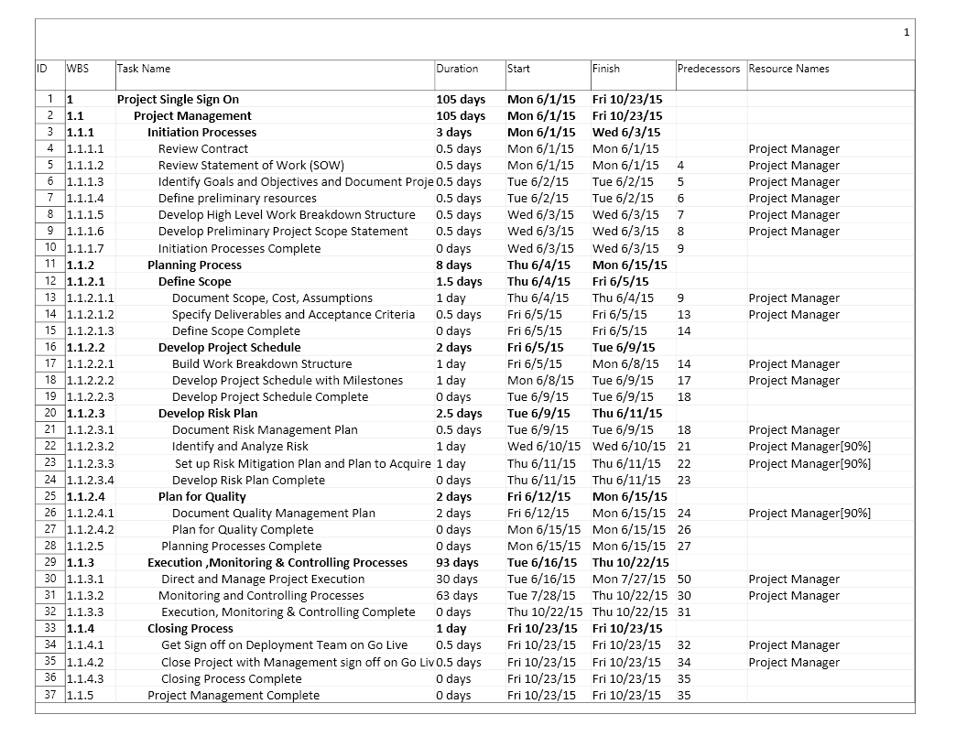
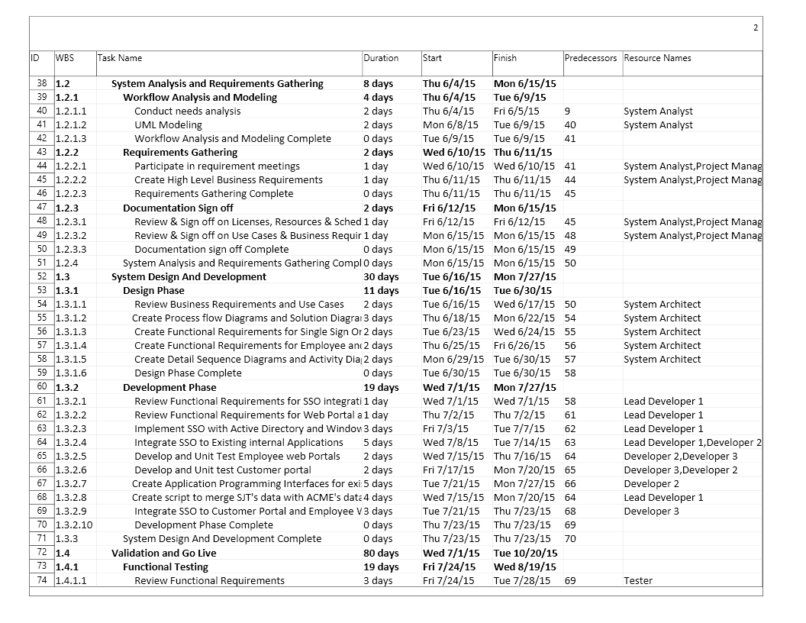
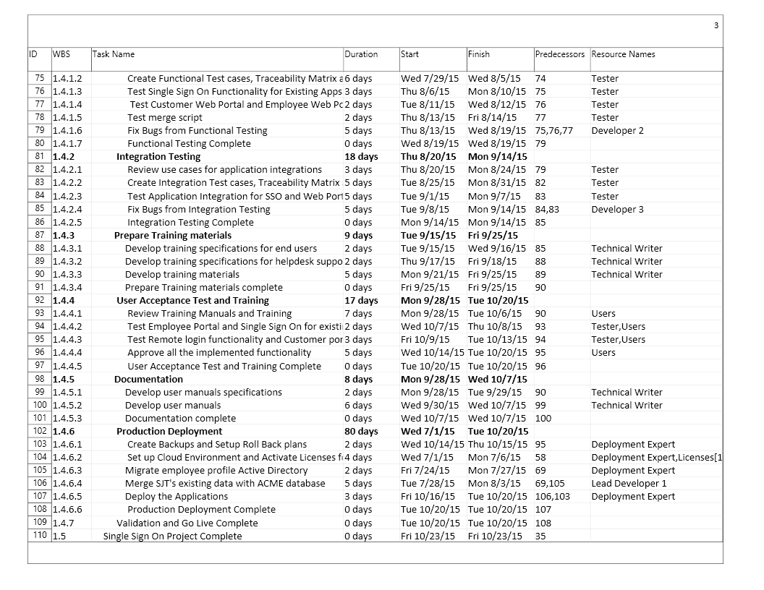

Resource Sheet. Resource sheet shows the list of resources and its rate.

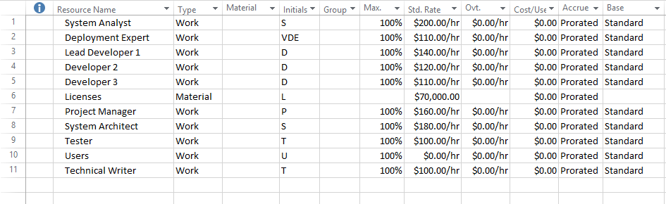

Cost Table – By Resource. This table displays the cost of resources.
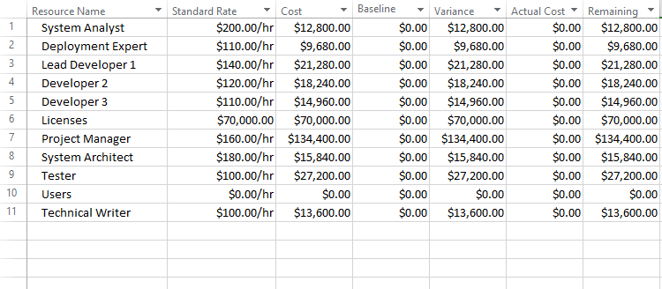

Cost Table – By Task. This table shows the cost of each task.
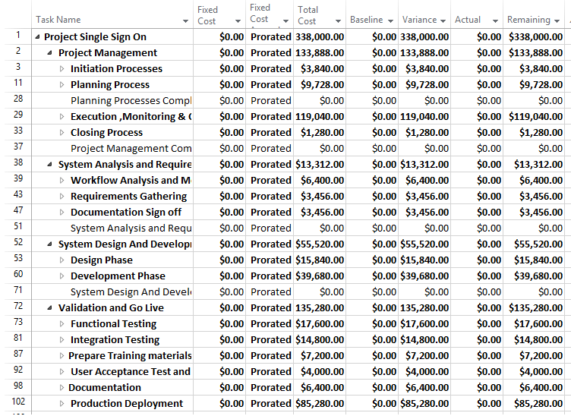

Resource Chart. This displays the resource’s work hours in a graphical view.
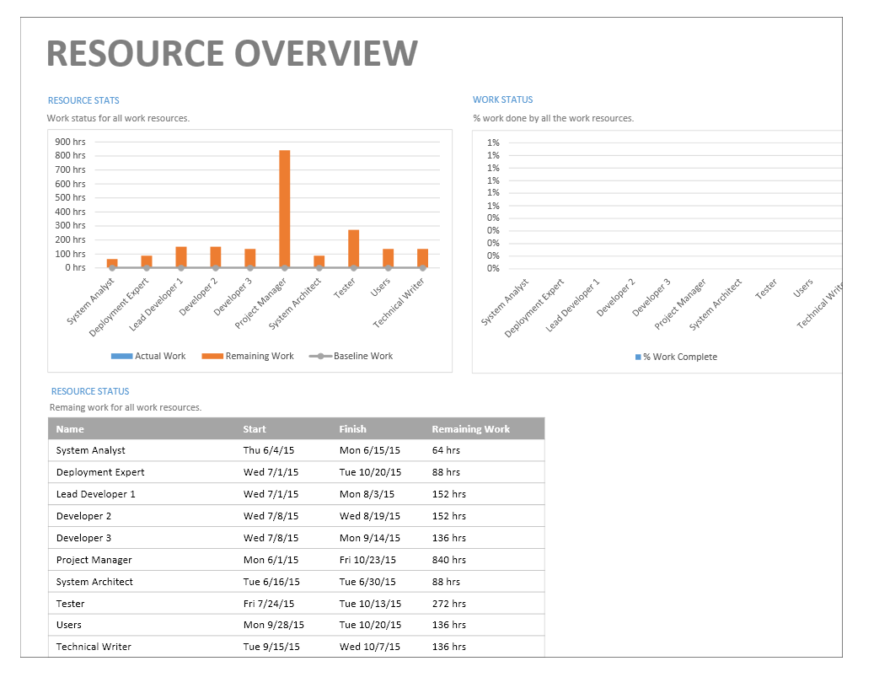

Resource Cost Overview. This provides the overview of the resource’s cost in graphical format.
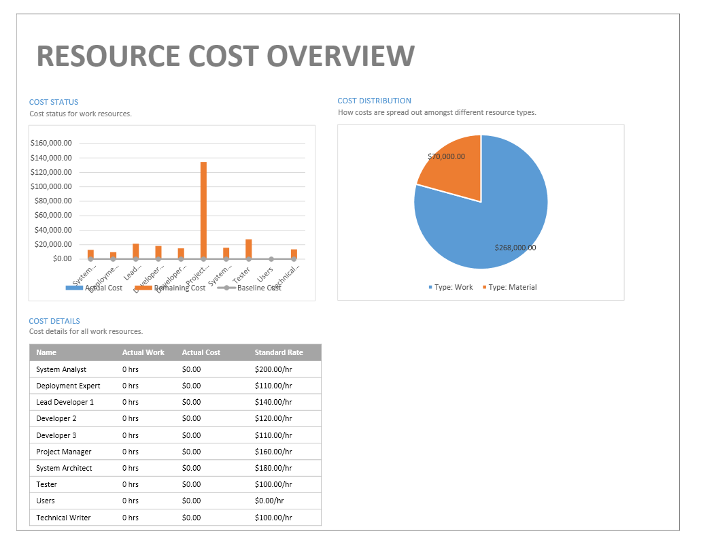
Project Monitoring and Control Plan. Project Monitoring and Control activities take place in parallel with Project Execution Process so that, while the project work is being executed, the project is being monitored and controlled by implementing the appropriate level of oversight and corrective action. Monitoring and Controlling process are continuously performed throughout the life of the project. Corrective actions may require revisiting the Planning process and update the project plan as needed with the ultimate goal of bringing the project back in line with project objectives and constraints, and improving future execution to avoid repeating the same issues.
Ensure The Project Is Going Smoothly. Instead of going through the four-model approach, we can begin with the logical model of the current system, a logical model of the new system, and a physical model of the new system. Create a Work Breakdown Structure with a project schedule and assign budgets to each work package to monitor and control the plan for the future of the project. Keep a to-do list and update it regularly, call a regular team meeting, praise the team for the accomplishment, keep trusting in my team’s strength and delegate the work that provides team members with opportunities to hone their skills. Try to reduce micromanagement, keep track of best practices, documenting and ensure to follow the process to run the project successfully. Hold regular team meetings which help me to distribute information, solicit feedback, set timelines, line up resources, and update all the stakeholders about the project status and all these will help the project go smoothly. In a nutshell, prioritize the to-do list or action program and use the talents, time, and expertise of other people on the team to help get the work done according to the plan.
Conduct an analysis similar like SWOT analysis in strategic planning to find the strengths, weaknesses, opportunities, and threats can be raised during the project life cycle. If needed go with Gap analysis to find out the gap between the current situation and the future state where we want to reach after the project completion. Later we can go for a detailed risk analysis to develop a risk management plan to identify and analyze the risks and verify and monitor that in each phase and create a risk response to update the project plan as per the additional necessity of resources and changes happening in the requirement. As part of the design phase, we will go with a prototype approach which will reduce the risk of the entire project plan in the future.
Some of the common project problems are connected to inadequate project definition, poor scope management, not managing the work plan, poor communication, poor quality management. We should give more focus in project planning and monitoring phase and implement a quality control process and quality assurance process to ensure all these issues have been taken care. A disaster recovery plan will be maintained to handle the unexpected failures. Keep day to day backup of the source code, database and documents as well as implement proper continuous integration like TFS, enhance proper security protection like antivirus etc., can be included as part of disaster recovery plan. We should monitor the critical path daily and make the adjustment in each phase to ensure the project is running smoothly.
Ensure That All Controls Are Adhered To. We can use Earned Value Management (EVM) to ensure that the project is running as per the project plan which helps to find variances in projects based on the comparison of worked performed and work planned. Each phase of the project, we should compare the overall baseline plan with the completed work package and make adjustments in the project plan if necessary. EVM can be used for measuring the project performance because it compares the amount of work that was planned with what was actually accomplished. It helps to track project and determine whether the remaining budget and resource will be sufficient to complete the rest of the work in time. This provides the project manager with an objective way of measuring performance and predicting future outcomes. Moreover, we should maintain a well defined documentation for each task and follow the quality assurance process in each phase to validate whether the project is satisfying with the expected quality acceptance criteria or not.
Timeline is another way to measure the project completion in project management. This helps to understand the completed work in a specific period of time because it displays the list of events in chronological order. Usually, timeline uses a linear scale, where a unit of distance is equal to a set amount of time. This time-scale is dependent on the events in the timeline.
Milestone based projects will help to evaluate the achievements in terms of the quantity and passed time of the work. Milestones allow project management to much more accurately determine whether or not the project is on schedule. Milestones are used to mark specific points along the project timeline. A milestone is considered as an identifiable phase that needs to be completed before beginning the next phase. We can mark the milestones in Timeline chart and Gantt Chart. Milestones are frequently used to monitor the progress, but there are limitations to their effectiveness. They usually show progress only on the critical path, and ignore non-critical activities.
Monitoring critical path is a vital factor to ensure the project is running smoothly. If the project is going out of the critical path, we should add more resources or change the timeline to adjust the critical path. We should look into the critical path daily and validate in each phase and apply the necessary actions if needed, to bring back the critical path in the normal state. And make sure that the coverage of all test cases and the test matrix are followed in the test event. We should control the scope creep by reducing the uncontrolled changes. This project plan will handle the change management and risk management throughout the project life-cycle. Keep another disaster recovery plan to protect from the effects of significant negative events. Work with the realistic and success team is another factor for the achievement of the project. Keep the timeline is very important to reach the project become the success. This plan has enough time like a contingency plan to respond coherently to an unplanned event. We can keep another contingency plan “Plan B” because it can be also used as an alternative for action if expected results fail to materialize.
Once the project is over, we should conduct a post-project review and auditing which will help us to validate, how the project was done and whether it accomplished its goal or not. This will be a big achievement for the future planning process.
Defined critical path. As per the Project Management Body of Knowledge (PMBOK) critical path means the sequence of schedule activities that determines the duration of the project (http://www.techrepublic.com). It is a step-by-step project management technique for process planning that defines critical and non-critical tasks with the goal of preventing time-frame problems and process bottlenecks. An activity on the critical path cannot be started until its predecessor activity is complete. As per the finish time point of view, the critical path is the longest path that determines the earliest finish time of the project. Tasks on the critical path are called critical tasks and non-critical tasks have some amount of 'FLOAT' or 'SLACK'. Slack is considered as the amount of time a task can be delayed without impacting the start date of a subsequent task. If the project schedule has multiple critical paths, then the project schedule is considered sensitive. If the project schedule has only one critical path and there is slack among the various tasks, then the project schedule is considered insensitive. Program Evaluation Review Technique (PERT), Critical Path Method (CPM), Gantt Charts and Network Diagram are helpful to find the critical path in the project schedule. Critical Path is related to the duration of each work. Project managers usually use a weighted formula to calculate the duration of the task. The project manager first makes three time estimates for each task, an optimistic, or best-case estimate (B), a probable-case estimate (P), and a pessimistic, or worst-case estimate (W). After that manager assigns a weight to each estimate. The weight can vary, but a common approach is to use a ratio of B = 1, P = 4, and W = 1. The expected task duration is calculated by (B+4P+W)/6 formula.
Gantt Chart. Gantt chart has a provision to filter, and display all critical tasks in a single chart. Here is the critical path of this project.

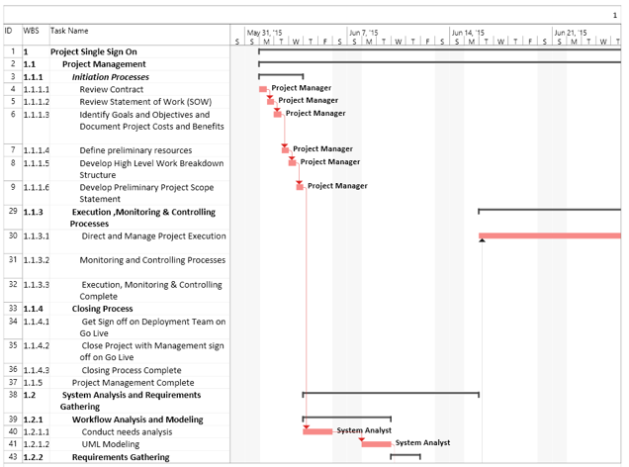
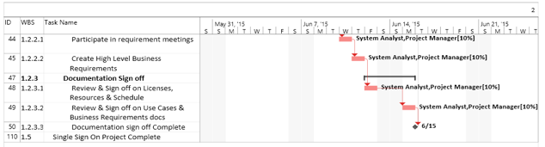
Network Diagram. Network diagram shows the dependencies between tasks in a graphical manner. The Network Diagram is another view that is helpful in understanding the critical path. The critical path showed in red color in this picture.
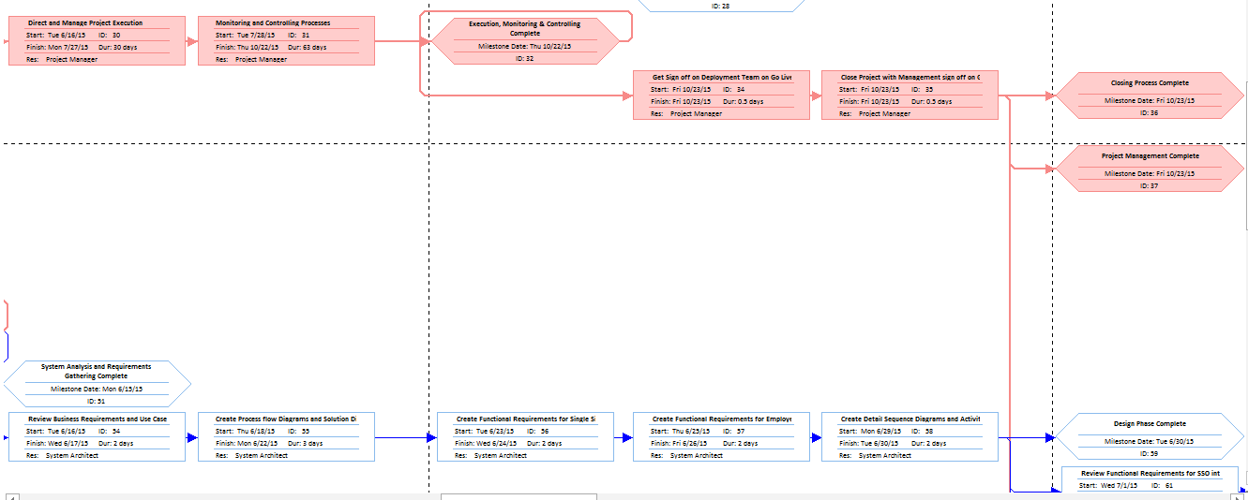

Critical Task Table. This displays the critical tasks in table format.
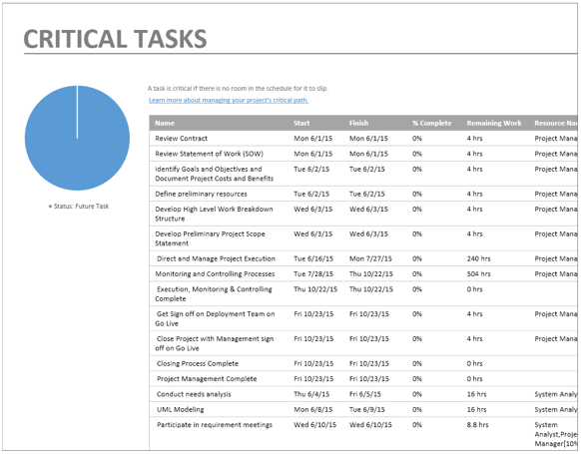
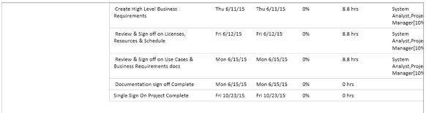
Timeline. Timeline is a high level view of this project plan that we can share through other Office applications such as PowerPoint and Outlook.
Estimated Amount of Time for Implementation. This project requires 2046 hours (man hours, 1 day = 8 hours) to complete the work within 105 days and its cost will be $338,000.00 as per my project plan.
Visual Representation of Timeline in Gantt Chart. This is the image of the Gantt Chart’s first page with a timeline.
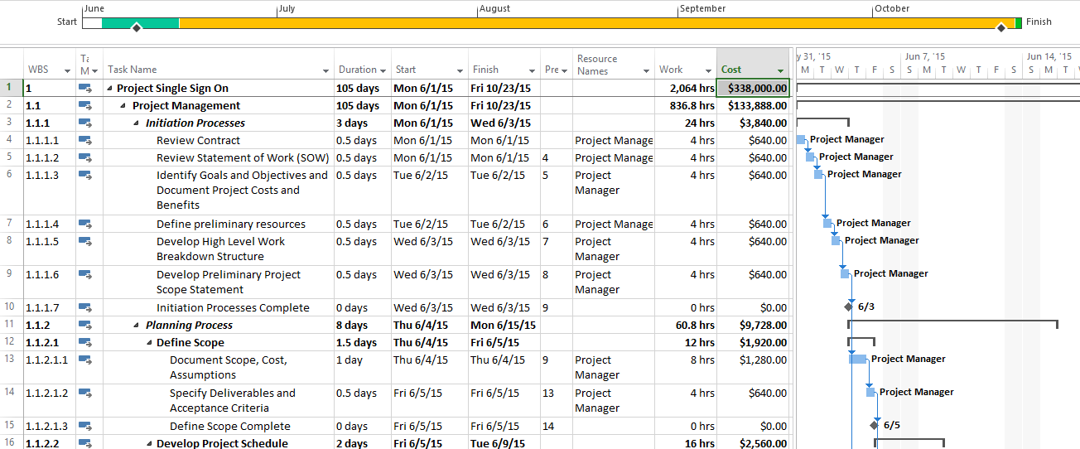

Timeline Fullview. This image shows the timeline in a single page without Gantt Chart
Start
Mon 6/1/15
Finish
Fri 10/23/15
June 1
July 1
August 1
September 1
October 1
Planning Process
Thu 6/4/15 - Mon 6/15/15
Execution ,Monitoring & Controlling Processes
Tue 6/16/15 - Thu 10/22/15
Closing Process
Fri 10/23/15
Initiation Processes
Mon 6/1/15 - Wed 6/3/15
Requirements Gathering
Wed 6/10/15 - Thu 6/11/15
Design Phase
Tue 6/16/15 - Tue 6/30/15
Development Phase
Wed 7/1/15 - Mon 7/27/15
Functional Testing
Fri 7/24/15 - Wed 8/19/15
Integration Testing
Thu 8/20/15 - Mon 9/14/15
Prepare Training materials
Tue 9/15/15 - Fri 9/25/15
User Acceptance Test and Training
Mon 9/28/15 - Tue 10/20/15
Documentation
Mon 9/28/15 - Wed 10/7/15
Deploy the Applications
Fri 10/16/15 - Tue 10/20/15
Develop Project Schedule Complete
Tue 6/9/15
Production Deployment Complete
Tue 10/20/15
Summary of the Project shows the start date, finish date, cost, duration and hours of work.

References
Rosenblatt, H. (2013). Systems analysis and design (10th ed.). Boston: Course Technology Cengage Learning.
Kendall, J. E. and Kendall, K. E. (2013). Systems analysis and design. (9th Ed.). Upper Saddle River, New Jersey: Pearson.
Harris, P. (2007). Prince 2 planning and control using Microsoft Project updated for Microsoft Office Project 2007. Victoria, Australia: Eastwood Harris Pty.
Microsoft.com. Claims-Based Single Sign-On for the Web and Microsoft Azure. Retrieved from
https://msdn.microsoft.com/en-us/library/ff359102.aspx
Microsoft.com. Claims-Based Architectures. Retrieved from
https://msdn.microsoft.com/en-us/library/ff359108.aspx
mindtools.com. Critical Success Factors. Identifying the Things That Really Matter for Success. Retrieved from
http://www.mindtools.com/pages/article/newLDR_80.htm
Modeling User Requirements. (n.d.). Retrieved from
https://msdn.microsoft.com/en-us/library/dd409376.aspx
Developing Models for Software Design. (n.d.). Retrieved from
https://msdn.microsoft.com/en-us/library/dd409436.aspx
Enterprise Data Modeling Tutorial. (n.d.). Retrieved from http://www.learndatamodeling.com/edm.php
What is data modeling? - Definition from WhatIs.com. (n.d.). Retrieved from http://searchdatamanagement.techtarget.com/definition/data-modeling
Data Modeling in System Analysis. (n.d.). Retrieved from http://www.umsl.edu/~sauterv/analysis/Fall2010Papers/varuni/
Watch. Learn. Pass Your PMP Exam. (n.d.). Retrieved from
https://www.project-management-prepcast.com/freetry-it/free-pmp-tips/pmp-exam-tips/302-pmp-exam-tip-the-work-breakdown-structure-wbs
What is a Control Plan? (2012, December 17). Retrieved from http://www.sixsigmadaily.com/what-is-a-control-plan/
20 Things Every Project Manager Should Know. (n.d.). Retrieved from http://www.corpedgroup.com/resources/pm/20ThingsPM.asp
Haughey, D. (n.d.). What is Earned Value? Retrieved from
http://www.projectsmart.co.uk/what-is-earned-value.php
Project Monitoring and Control Activities. (n.d.). Retrieved from http://www.pmdocuments.com/project-monitoring-and-control-documents/
Why critical path is critical to project management. (n.d.). Retrieved from http://www.techrepublic.com/blog/tech-decision-maker/why-critical-path-is-critical-to-project-management/

